1.1 Areas Between Curves

A Quick Review:

Example: Let A be the area of the region that lies above the x-axis and under the graph of between & . Estimate the area by using a Right Riemann Sum with 4 rectangles.

Definition: If f is a continuous function on , then the definite integral of f from a to b is

provided that this limit exists and gives the same value for all possible choices of sample points . If it does exist, we say that f is integrable on .

Areas Between Two Curves:

General Idea:

Definition (Area Between Two Curves w/respect to x): The area A of the region bounded by the curves , and the lines , where f and g are continuous and for all x in , is

Example 1: Find the area of the region bounded by .

Example 2: Find the area of the region bounded by the curves .

Example 3: Find the area enclosed by the curves .

Integrating with Respect to y (instead of x)

General Idea:
We should note that not all curves can regarded y as a function of x. Some curves are best treated as , where x is a function of y. If we consider the picture below we can see that we can still use the idea of a Riemann sum.
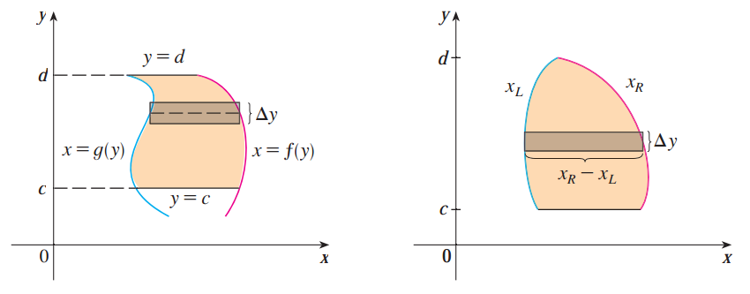

Definition (Area Between Two Curves with respect to y): The area A of the region bounded by the curves , and the lines , where f and g are continuous and for all y in , is

Example 3 (continued): Find the area enclosed by the curves .

Example 4: Find the area enclosed by the curves and the x-axis.

- Find this area by integrating with respect to y.

- Find this area by integrating with respect to x.

